GWIRA UWAMAHORO BENIE KELIA
28821
ALL REQUIRED SCREENSHOTS
SQL JOINS
INNER JOIN
-- Retrieve all transactions that have valid matching customers and products
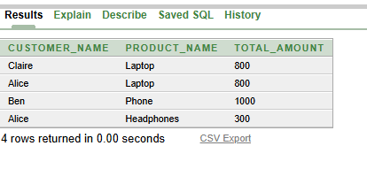
Business interpretation
his query helps the business focus only on real, completed transactions where both the customer and the product exist. It ensures that reports or analyses don’t include invalid or incomplete data.
LEFT JOIN
-- Identify customers who have never made a transaction
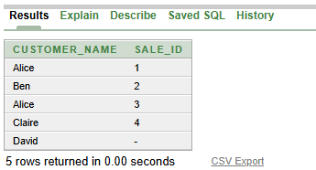
Business interpretation:
The business can use this to spot inactive or dormant customers. Targeted marketing campaigns or promotions can then be designed to engage these customers and boost sales
RIGHT JOIN
-- Detect products that have no sales activity
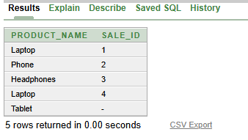
Business interpretation:
This helps the company identify products that aren’t selling. Management can decide whether to promote, discount, or discontinue these products to optimize inventory.
FULL OUTER JOIN
-- Compare all customers and products, including unmatched records on either side
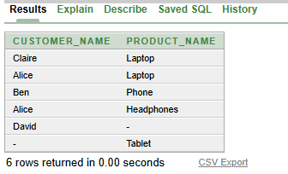
Business interpretation:
This gives a complete overview of customers and products, including gaps in transactions. It can highlight both inactive customers and unsold products, helping in strategy planning.
SELF JOIN
-- Compare customers within the same region or transactions within the same time period
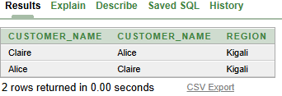
Business interpretation:
This allows the business to find patterns or similarities among customers or transactions. For example, it can reveal regional buying trends or peak sales periods, which helps in targeting promotions and stock planning.
WINDOW FUNCTIONS IMPLEMENTATION
RANKING FUNCTIONS
-- Rank top customers and products by revenue
TOP CUSTOMER BY REVENUE
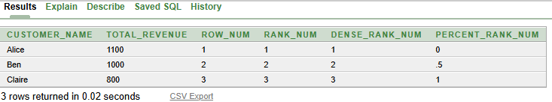
TOP PRODUCT BY REVENUE
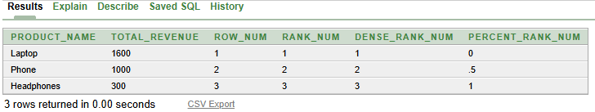
Business interpretation:
This helps the business quickly identify the highest-performing customers and products. It supports strategic decisions like rewarding loyal customers, prioritizing top products in marketing, and optimizing inventory for high-demand items.

AGGREGATE WINDOW FUNCTION
-- Calculate running totals and track revenue trends over time
RUNNING TOTAL SALES BY DATE
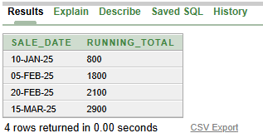
3 MONTHS MOVING AVEREAGE USING RANGE FOR TRENDS
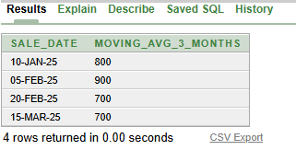
Business interpretation:
The business can monitor cumulative performance and detect growth patterns or slowdowns. This insight helps in forecasting sales, managing cash flow, and making timely operational decisions.
NAVIGATION FUNCTION
-- Compare data period-to-period to measure growth or decline
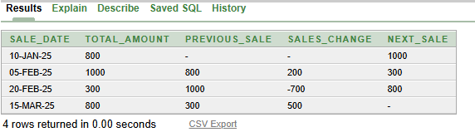

Business interpretation:
By comparing performance across periods, the business can spot trends and measure growth rates. It enables management to evaluate the effectiveness of strategies and adjust plans to maximize revenue or reduce losses.
DISTRIBUTION FUNCTIONS
-- Segment customers based on revenue or other metrics
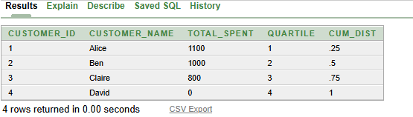
Business interpretation:
Customer segmentation allows the business to categorize clients into meaningful groups, such as high-value or low-value customers. This supports targeted marketing, personalized promotions, and resource allocation for better customer retention and profitability.

SCHEMA
Customer (customer _ id PK, customer _name, region)
Product (product _ id PK, product _name, category, price)
Sales (sale _id PK, customer _id FK, product _id FK, sale _date, quantity, total _amount)
ER DIAGRAM

